**17/09/2021 OOAD LAB 3 2019103573**

**EXCERSISE 3 - CLASS DIAGRAMS FOR CASE STUDIES**

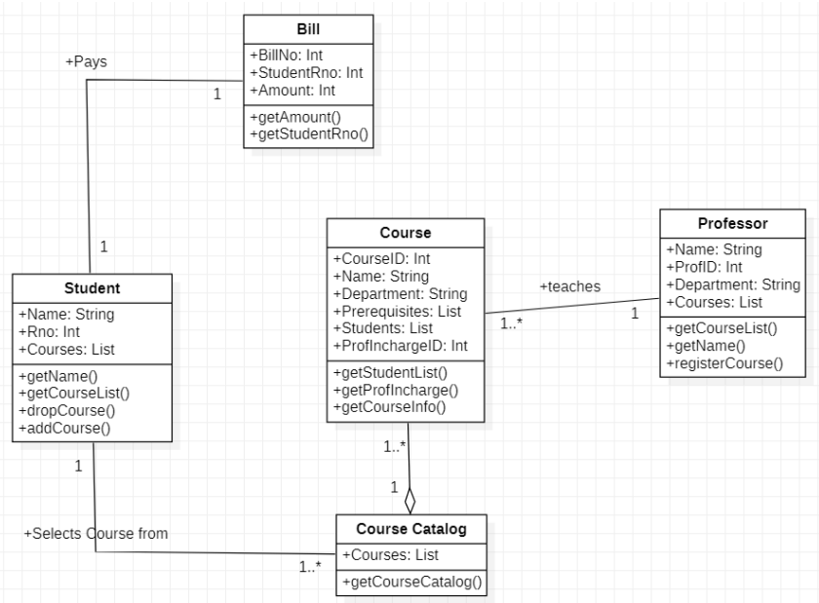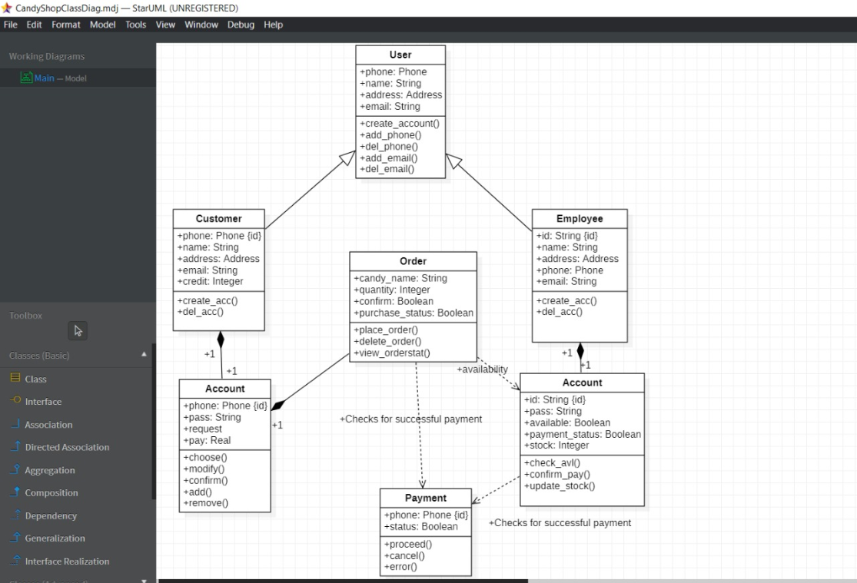**CASE STUDY 1: CLASS DIAGRAM FOR COURSE REGISTRATION**

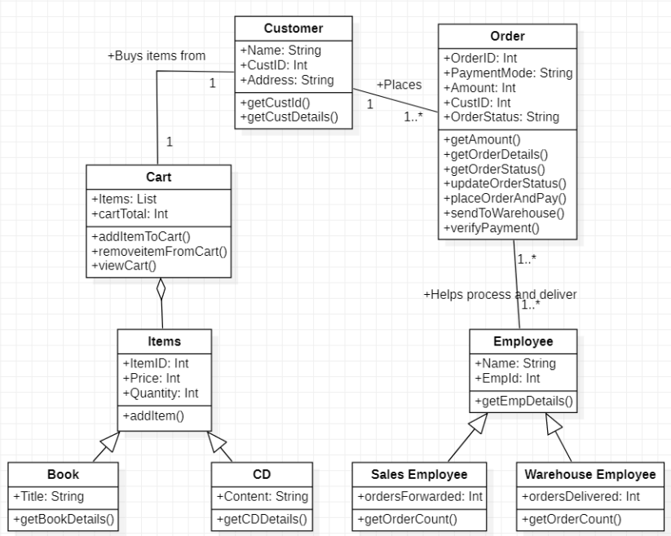**CASE STUDY 2: CLASS DIAGRAM FOR ONLINE BOOK SHOPPING**

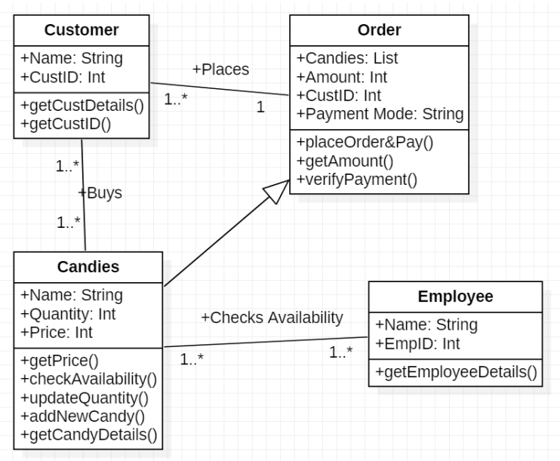**CASE STUDY 3 : CLASS DIAGRAM FOR CANDY STORE**